

[Faculty of Arts & Sciences](https://www.usal.edu.lb/faculty-of-arts-sciences/)

COMPUTER SCIENCE DEPARTMENT

**Retirement and Compensation Calculator: Planning Your Financial Future**

Project prepared by:

Mariam Srour ID: 1121115

In partial fulfillment of the course

Advanced Programming

[COMP305](https://moodle.usal.edu.lb/lms/course/view.php?id=4034)

Spring 2022-2023

Every person can request a retirement pension or compensation, and this project aims to facilitate the process of calculating the legal salary. Through this project, retirement pensions or compensations provided to individuals in the educational structure of private schools will be calculated. It will assist the employees in ensuring accurate calculation of the compensatory salary or retirement pension based on confirmed conditions required for this service. Additionally, it will calculate the amount to be paid to the individual based on multiple laws and the duration of work.

First, the user is required to enter their full name, date of birth, start date of employment, and end date of employment. They can input this information using an appropriate GUI form, as shown in the following example:

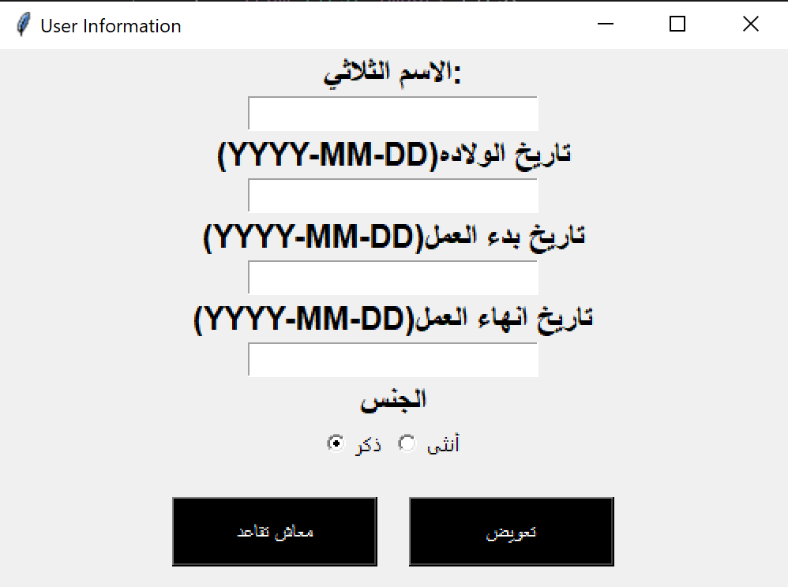

If the user enters incorrect or invalid dates, the system will display a message box notifying them about the incorrect format. The message box will inform the user that the dates they entered are in the wrong form, prompting them to input the dates correctly. This will help ensure that the system receives the required information in the correct format.

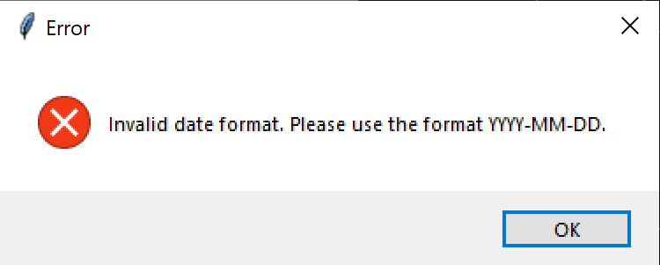

Afterward, the program will calculate the number of years the user has worked and their current age. It will then exclude any years of work prior to turning 18 and any years worked after reaching the age of 64, as these are not considered valid working years. This ensures accurate calculation of the user's total years of work.

After providing the system with all the aforementioned information, the user will have the option to choose between retirement pension or compensation by clicking on the corresponding button. As shown the system includes buttons labeled with the words "Retirement Pension" and "Compensation" to facilitate the selection process for the user.

If the user selects the retirement pension option, there are two conditions that must be met simultaneously for the user or service applicant to be eligible for it. The first condition is that the user's age should not be less than 55 years, and the second condition is that the duration of their work should not be less than 30 years. The system can automatically verify if these conditions are met without requiring the user to enter any additional information. It can validate these conditions based on the calculated age and duration of work.

If either or both of the conditions are not met, the system will display a red error message indicating that the required conditions are not fulfilled. The error message will inform the user that they are not eligible to receive the retirement pension due to the absence of the necessary conditions.



If the user chooses compensation as their desired service, they must meet at least one of the following five conditions:

1. For females, they must be married.

For both males and females,

1. The duration of education should be more than 25 years.
2. They should have reached the age of 64.
3. They should have a medical condition.
4. They should be deceased.

The system can verify if the user has reached the age of 64 or if the duration of education is more than 25 years. If either of these conditions is met, the user is eligible to receive compensation. In this case, the system does not need to ask the user any further questions.

However, if these two conditions are not met, the system will ask the user to select from the following options using checkboxes:

* Medical condition (checkbox)
* Deceased (checkbox)
* Female and married (checkbox)

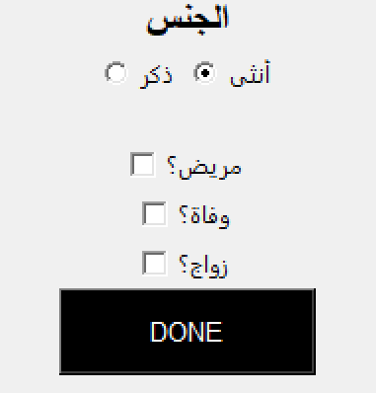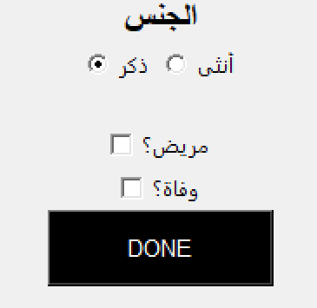

If the user does not meet any of these conditions and has not selected any of them, they will not be eligible to use the service. In this case, the system will display a sentence stating that the required conditions are not met and, therefore, the user cannot benefit from this service.

C:\Users\Mariam\AppData\Local\Microsoft\Windows\INetCache\Content.Word\errorrr.PNG

If the eligibility conditions for either the retirement pension or compensation are met, the system will proceed to calculate the legal salary. This calculation will allow us to determine the value of the compensation or retirement pension.

The exact formula for calculating the legal salary may vary depending on the specific regulations and laws governing retirement benefits or compensation in the given context. The system will utilize the appropriate formula and variables to calculate the accurate value of the compensation or retirement pension based on the provided information.

The user selects the certificate they have obtained for which they are requesting the service. Additionally, there is a field where they can specify whether they were a secondary education teacher.

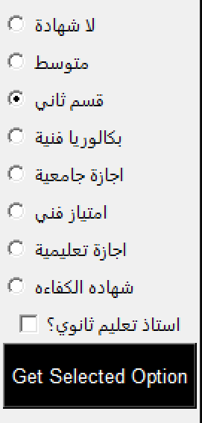

To calculate the number of months worked, the following method is used:

* For the first 10 years of work, each year is considered as 1 month.
* For the subsequent 20 years (from year 11 to year 30), each year is considered as 2 months.
* After 30 years of work, each year is considered as 3 months.

To calculate the legal salary, the following rules apply:

Regular Grades:

* Every 2 years of teaching experience, one additional grade is added.

Additional Grades for Normal Cases:

* Law 80: Teachers who started working before the year 1977 receive one additional grade.
* Law 81: Teachers who started working in or before the year 1978 receive two additional grades.
* Law 244: All teachers except secondary education teachers receive three additional grades.
* Law 102: All teachers except secondary education teachers receive three additional grades.
* Law 148: Only secondary education teachers receive six additional grades.
* Law 223: Teachers who started working in or before the year 2009 receive 4.5 additional grades. If they started working after 2010, they receive four additional grades.
* Law 159: Only secondary education teachers receive four additional grades.
* Law Q 46: Teachers who started working in or before the year 2007 receive six additional grades.

The system automatically calculates these laws, regular and exceptional grades on its own. It is designed to do so.

Here are the calculations for the different certificates:

* Middle School Certificate (شهادة متوسط): Regular grades + Exceptional grades
* Secondary Specialization Certificate (قسم ثاني): Regular grades + Exceptional grades If the user started working in 1994, 1995, or 1996, an additional grade is added.
* Technical Baccalaureate (بكالوريا فنية): Regular grades + Exceptional grades + 6 additional grades
* University Degree (اجازة جامعية): Regular grades + Exceptional grades + 6 additional grades
* Technical Distinction (امتياز فني): Regular grades + Exceptional grades + 11 additional grades
* Teaching License (اجازة تعليمية): Regular grades + Exceptional grades + 14 additional grades
* Proficiency Certificate (شهادة الكفاءة): Regular grades + Exceptional grades + 16 additional grades
* If the user doesn't have a certificate (بدون شهادة), then it is considered as the end of service year minus 1996, subtracted by 2. Additionally, 1996 minus the starting year of work is added, multiplied by three, plus the number of exceptional grades.

When calculating the number of months and grades, it is possible to calculate the legal salary. The legal salary is determined based on the grades. It is possible to determine the salary for one month, and then multiply the salary by the number of months.

If the requested calculation is for retirement pension, the pension amount is 85% of the legal salary. For compensation, it is equal to the legal salary. The system will provide the user with the answer in green color.

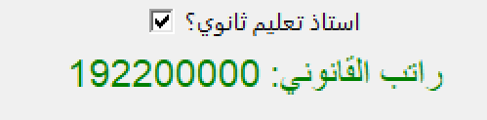

Additionally, there is a feature where the system can explain how the calculation was performed if the user wants to understand why that specific number is the result.

